AI Research Orchestrator
A multi-agent AI system that automates comprehensive research workflows. Given a research query, the orchestrator intelligently plans, searches, analyzes, summarizes, and generates structured research reports using a coordinated team of specialized AI agents.

Core Idea
The AI Research Orchestrator breaks down complex research tasks into a multi-stage pipeline where specialized agents collaborate:
- Planner Agent → Decomposes the query into research topics, search queries, and analysis steps
- Web Search Agent → Retrieves relevant content from the web and indexes it into a vector store
- Analyzer Agent → Extracts key findings, evidence, and insights from the retrieved content
- Summarizer Agent → Creates a concise academic-style summary
- Report Generator Agent → Produces a comprehensive, structured markdown report
The system uses LangGraph for orchestration, enabling conditional routing, retry logic, and state management across the pipeline. All agents share a common state object that flows through the graph, allowing each agent to build upon previous work.

Architecture

System Architecture Diagram

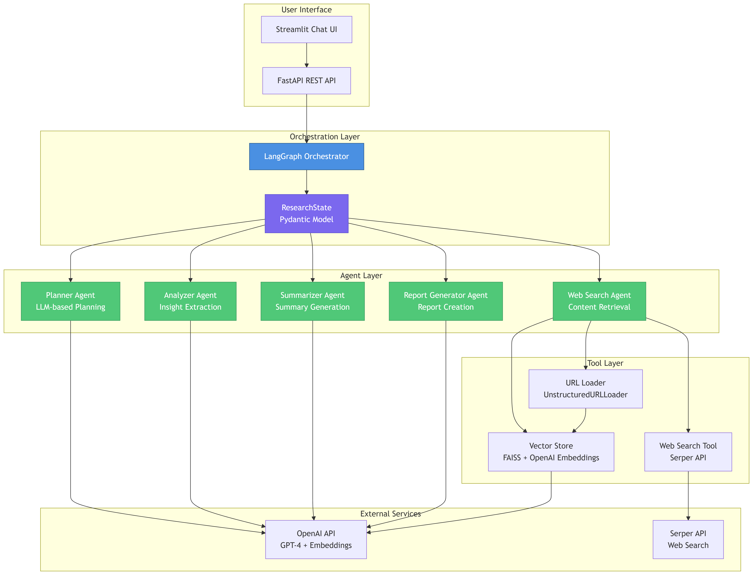

Workflow Diagram

Tech Stack
- Language: Python 3.11+
- Orchestration: LangGraph (stateful multi-agent workflows)
- API Framework: FastAPI
- LLM: OpenAI API (GPT-4 for agents, text-embedding-3-small for embeddings)
- Vector Store: FAISS (in-memory similarity search)
- Web Search: Serper API (Google search results)
- Content Extraction: LangChain UnstructuredURLLoader
- State Management: Pydantic models
- UI: Streamlit (conversational chat interface)
- Logging: Centralized logging to console and `logs/runing_logs.log`

Project Structure
AI_Orchestra/
├── app/
│ ├── __init__.py # Logging configuration
│ ├── main.py # FastAPI endpoints
│ ├── orchestrator.py # LangGraph orchestration logic
│ ├── state.py # ResearchState Pydantic model
│ ├── llm.py # OpenAI LLM wrapper
│ ├── agents/
│ │ ├── planner.py # Breaks query into structured tasks
│ │ ├── search_agent.py # Web search + content extraction
│ │ ├── analyzer.py # Extracts insights from content
│ │ ├── summarizer.py # Generates concise summary
│ │ └── report_generator.py # Creates structured markdown report
│ └── tools/
│ ├── web_search.py # Serper API integration
│ ├── url_loader.py # UnstructuredURLLoader wrapper
│ └── vector_store.py # FAISS vector store with OpenAI embeddings
├── app.py # Streamlit UI entrypoint
├── requirements.txt # Python dependencies
├── .env # Environment variables (API keys)
├── logs/
│ └── runing_logs.log # Application logs
└── output/ # Generated markdown reports

Quick Start

1. Installation

# Create virtual environment
python -m venv env
# Activate virtual environment
# Windows PowerShell:
.\env\Scripts\Activate.ps1
# Windows CMD:
.\env\Scripts\activate.bat
# Linux/Mac:
source env/bin/activate
# Install dependencies
pip install -r requirements.txt

2. Environment Setup
Create a `.env` file in the project root:
OPENAI_API_KEY=sk-your-openai-key-here
SERPER_API_KEY=your-serper-api-key-here

3. Run the Streamlit UI
streamlit run app.py
Open your browser to `http://localhost:8501` and start asking research questions!

4. Run the FastAPI Server (Alternative)
uvicorn app.main:app --reload
The API will be available at `http://127.0.0.1:8000`.

API Endpoints:
- `GET /health` - Health check
- `POST /research` - Run research orchestration

Example Request:
{
"query": "Explain the current state of research on retrieval-augmented generation."
}

How It Works

1. Planner Agent
- Takes the user query
- Uses LLM to generate:
- `research_topics`: List of topics to explore
- `search_queries`: Optimized search queries
- `analysis_steps`: Steps for analysis

2. Web Search Agent
- Executes search queries using Serper API
- Retrieves URLs and metadata
- Uses `UnstructuredURLLoader` to extract full page content
- Indexes content into FAISS vector store for future RAG

3. Analyzer Agent
- Processes search results
- Extracts structured insights:
- `finding`: Key finding or claim
- `evidence`: Supporting evidence
- `source`: Source URL/title

4. Summarizer Agent
- Synthesizes extracted insights
- Generates a 300-500 word academic-style summary
- Neutral tone, structured paragraphs

5. Report Generator Agent
- Creates comprehensive markdown report with sections:
1. Introduction
2. Background
3. Key Findings
4. Trends
5. Challenges
6. Conclusion
7. References
- Saves report to `output/{query}.md`

Conditional Logic
- Search Retry: If `search_results` is empty and `search_attempts < 2`, retry search
- Error Handling: If `extracted_insights` is empty, mark error state and stop

State Management
The `ResearchState` Pydantic model flows through all agents:

class ResearchState(BaseModel):
user_query: str
research_topics: List[str]
search_queries: List[str]
analysis_steps: List[str]
search_results: List[dict] # {title, source, content, url}
extracted_insights: List[dict] # {finding, evidence, source}
summary: str
final_report: str
status: str # pending|running|completed|error
error: Optional[str]
search_attempts: int

Logging
All operations are logged to:
- Console: Real-time output with timestamps
- File: `logs/runing_logs.log` (UTF-8 encoded)
Log format: `[YYYY-MM-DD HH:MM:SS]: message`

Configuration

Vector Store
- Embedding Model: `text-embedding-3-small` (1536 dimensions)
- Index Type: FAISS `IndexFlatIP` (Inner Product for cosine similarity)
- Storage: In-memory (not persisted to disk)

LLM Models
- Default: `gpt-4o` (configurable via `OPENAI_MODEL` env var)
- Embeddings: `text-embedding-3-small`

Output
Generated reports are saved as markdown files in the `output/` directory:
- Filename: Sanitized version of the user query
- Format: Structured markdown with sections
- Encoding: UTF-8

Contributing
This is a research project demonstrating multi-agent orchestration with LangGraph. Feel free to extend it with:
- Additional agents (e.g., fact-checker, citation validator)
- Persistent vector store (save/load FAISS index)
- More sophisticated retry logic
- Real-time progress updates in UI
- Voice input integration

